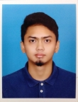

**Ameirul Azwa Bin Lela**

*Seeking a mechanical engineering position to cultivate the talents and knowledge learnt through the challenges and experiences which can contribute to organizational objectives.*



**RELATED SKILLS**

**Software:** AutoCAD, Creo Parametric/Simulate (Pro/ENGINEER), SAP, LaTeX, MATLAB, MS-Office (Words, Excel, PowerPoint).

**Machining Tools:** Mills, lathes, band saw, drill presses, CNCs, etc.

**Language:** English and Malay

**Sport:** Futsal, Badminton, Volleyball

**INFORMATION**

* JB 2113, Jln Seri 16, Tmn Seri Serkam, 77300, Merlimau, Melaka, Malaysia

✆ 011-12274349  
🖂 ameirul.azwa@gmail.com  
Expected salary: Negotiable



**EDUCATION**

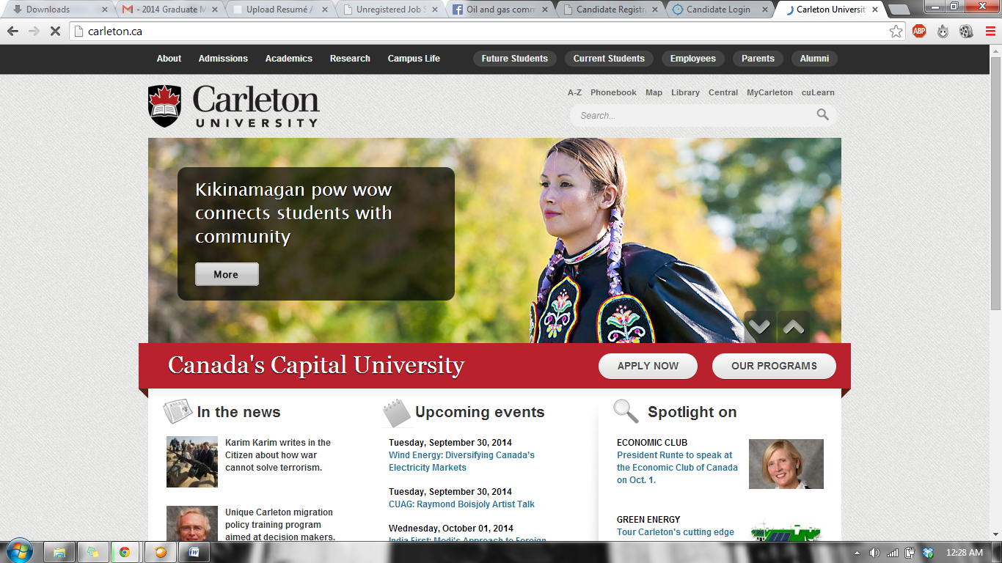

**Carleton University, Ottawa, Canada** (June 2014)

*Bachelor of Engineering in Mechanical Engineering*

CGPA: 10.16 in the 12-scale system

*(Equivalent to 3.73 in the 4-scale system)*

**Taylor’s University College, Subang Jaya, Malaysia** (June 2010)*Ontario Secondary School Diploma*

**Sekolah Berasrama Penuh Integrasi Selandar** (2008)*Malaysian Education**Certificate*, 9A ‘s and 1B



**PROFESSIONAL EXPERIENCE**

**Top Glove Corporation Berhad** (Klang, Selangor, MY)

*The world’s largest glove manufacturer*

**Chlorination Engineer,** Dec 2014-present

* Troubleshoot daily glove quality issue related to chlorination process
* Improve production process for better cost saving and safety
* Design and manage project for setting up chlorination system in new factory
* Liaison for Government affairs for Chlorination - DOSH and DOE

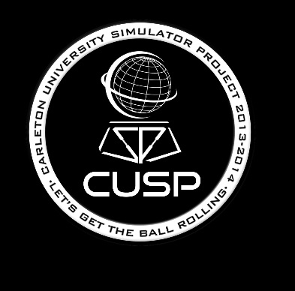

**Carleton University Simulator Project**

*Website: http://2013cusp.mae.carleton.ca/*

* Designed 3D model of the external structure of the simulator platform using Creo Parametric (Pro Engineer).
* Performed load analysis to the design for verification.
* Involved directly during the manufacturing process of the components. Became adept at manufacturing process in the machine shop.
* Contributed ideas for designs and work process during the project meetings.
* Save production cost for using different material for better performance and strength

**FINAL YEAR PROJECT**



**ACADEMIC COURSES**

Engineering Dynamics, Thermodynamics and Heat Transfer, Engineering Materials, Engineering Graphical Design, Mechanics of Solids, Fluid Mechanics, CAD/CAM, Principles of Manufacturing, Mechanical System Design, Finite Element Methods, Heat Transfer, Materials: Strength and Fracture and Mechanics of Deformable Solids.



**AWARDS & SCHOLARSHIPS**

2014 Dean’s Honour List

2012 Dean’s Honour List

2012 David A. Golden Scholarship

2011 Dean’s Honour List

2011 Murdoch Maxwell MacOdrum Scholarship

2010 Carleton University Entrance Scholarship

2008 Excellent Student Award